Title: Global Prediction of Hospital Stay in Traumatic Brain Injury Using Transfer Learning: A Multinational, Multicenter Study

Abstract
Objective
Length of stay (LOS) after traumatic brain injury (TBI) is influenced by both clinical severity and system-level pressures, yet most prognostic models are built on single datasets and face challenges in generalizing across diverse settings. Few-shot transfer learning (TL) allows models trained on one population to be adapted to new cohorts with minimal data, improving performance in resource-limited, heterogenous contexts. We evaluate whether TL with can improve LOS survival modeling across international TBI cohorts.

Study Design
A retrospective, multi-cohort machine-learning study applying few-shot transfer learning to global survival models.

Methods
We analyzed four TBI cohorts spanning India, Jordan, Florida (USA), and California (USA), each representing distinct populations: the Indian dataset was multi-center, the Jordanian cohort consisted of pediatric patients, the California cohort had adults with measured blood alcohol concentration, and the Florida cohort comprised adults with severe blunt TBI admitted to intensive care. Gradient Boosting Survival Analysis models were trained under baseline, standard TL, and weighted TL conditions. Few-shot fine-tuning was performed using 5%, 10%, and 20% of target cohort data and evaluated using the concordance index (C-index) and time-dependent AUC.

Results
Transfer learning consistently provided stronger C-indices compared to baseline models, with the greatest gains at the 5% and 10% fine-tuning levels. Weighted TL achieved the largest gains, raising C-index from 0.16 to 0.69 (India→Jordan) and from 0.51 to 0.86 (India→California) with only 5% of target data. Benefits were diminished when transferring between similar cohorts (e.g., Florida↔California).

Conclusion
Few-shot TL improves LOS prediction across heterogeneous TBI cohorts, providing a data-driven strategy for global prognostication and resource planning. Prospective validation and extension to rural populations are needed.

Keywords: Traumatic Brain Injury, Length of Stay, Transfer Learning, Survival Analysis, Machine Learning

Introduction
Traumatic Brain Injury (TBI) causes an estimated 27.16 million new cases globally in 2019 and contributes 7.08 million years lived with disability (YLDs) worldwide.¹ TBI remains a major contributor to global morbidity, mortality, and long-term disability across age groups.² Each year, tens of millions of people sustain TBIs, and a substantial proportion suffer lasting physical, cognitive, or psychological impairments requiring extensive care.³ Early risk stratification is important in guiding acute clinical decision-making and triage in TBI.^{4,5}

TBI burden and outcomes vary intensively across geography, with low/middle-income countries bearing a disproportionate share of disability and deaths.⁶ Mortality following TBI is 2–3 times higher in low- and middle-income countries, due to gaps in pre-hospital care, delays to neuroimaging, and limited neurosurgical resources.⁷ Resource-constrained settings generally lack strong emergency care infrastructure and access to neuroimaging or neurosurgical services, which limits both clinical care and data collection. Building local prognostic models in such settings is challenging due to small sample sizes, missing data, and heterogeneity in injury mechanisms and care pathways.⁵ Several prognostic models have been developed for TBI, including well-known scoring systems such as IMPACT and CRASH built on large prospective cohorts using traditional regression methods.^{4,5}

These models often derive from internal datasets and may lack generalizability to external or global populations.⁴ More recently, machine learning approaches have been used to predict outcomes such as prognosis and length of hospital stay in TBI.⁴ For instance, Babel et al. (2025) applied ML to predict prolonged hospital stay in TBI, but dichotomized length of stay based on varied definitions, limiting interpretability and consistency.⁵ Such machine‑learning models typically use single datasets, raising concerns about generalizability when applied to different regions or care systems. This limitation is especially consequential in global health contexts, where regional differences in epidemiology, infrastructure, and clinical protocols require model adaptation rather than direct transfer.

Transfer learning offers a potential solution by enabling domain adaptation and generalization in contexts with scarce local data.⁸ Few‑shot learning, a form of transfer learning, allows models pretrained on larger source populations to be fine‑tuned using minimal target data—critical for deployment in real‑world, data‑limited clinical settings.⁹ This approach can benefit regional healthcare systems that lack sufficient sample size to train standalone survival models from scratch. We frame the prediction of hospital length of stay (LOS) in TBI as a time‑to‑event (survival) task. LOS serves as a proxy for clinical complexity and resource consumption, making it useful for optimizing health systems, planning discharges, and allocating resources, particularly in environments with constrained hospital capacity.⁴ Since in‑hospital mortality is common in TBI, survival analysis must incorporate censoring when calculating LOS outcomes ¹⁰

Our study evaluates cross-cohort transfer learning using few-shot survival modeling across multiple epidemiologically distinct TBI datasets. With pre-trained survival models from source cohorts and fine-tuning with limited local data, we aim to improve LOS prediction performance and generalizability.

Methods
The transfer learning framework and research methodology are shown in Figure 1. We assessed four TBI cohorts from separate epidemiological contexts, three of which were harvested from open-access datasets while one was retrospectively collected from our institution.^{11–13} The data characteristics and feature space are shown in Supplemental Table 1. We did not approach the cohorts as directly interchangeable populations because they varied significantly in terms of patient demographic, geographic environment, mechanisms of injury, and clinical context. Each source-target combination represents a degree of domain shift across populations, and the heterogeneity was instead seen as a component of the transfer learning problem.

For cross-cohort transfer learning, datasets were cleaned and preprocessed to retain a harmonized feature set limited to variables consistently across cohorts; demographics such as age and sex, the first recorded systolic blood pressure (SBP), heart rate (HR), respiratory rate (RR), the initial Glasgow Coma Scale (GCS), and mechanism of injury (MOI) were input features. SBP, HR, and RR were categorized into age-specific thresholds, such as “within normal limits,” “tachycardia/tachypnea,” and “low blood pressure,” using published clinical reference ranges. Mechanisms of injury were also harmonized in each dataset to the following classes: motor vehicle collision (MVC), motorcycle crash, bicycle crash, pedestrian struck, fall, assault/blunt force trauma, gunshot wound (GSW), burn/fire/blast, animal/environmental, and other/unknown. For example, uncommon injuries, such as “alligator bite,” were subsumed under “animal/environmental.” These categorical features, along with the MOI, were one-hot encoded using a unified encoder. All missing features were imputed using an Iterative Imputer with a Bayesian Ridge estimator. LOS was the primary outcome of interest and was treated as a time-to-event variable, with hospital discharge as the event of interest and in-hospital mortality serving as a censoring indicator where applicable. We selected this approach because death would preclude the observation of subsequent discharge time; we nonetheless acknowledge that mortality may also represent as an informative competitive event in severe TBI rather than purely administrative censoring.

We adopted a cross-cohort transfer learning protocol, where one dataset was designated as the source domain and another as the target. The protocol was applied in a few-shot learning framework to simulate real-world data limitations in prospective or online model deployment, where only a small proportion (5%, 10%, and 20%) of the target data was used for model fine-tuning. We trained survival models using Gradient Boosting Survival Analysis (GBSA), a tree-based ensemble survival model adapted for right-censored data. GBSA is an additive, tree-based ensemble model adapted for predicting a risk score function$F(x)$ from right-censored data:
$$F(x) = \sum_{m=1}^{M}{v∙h_{m}(x)}$$
where $h_{m}(x)$ is the prediction from the mth base learner (regression tree) at a learning rate $v$ over $M$boosting iterations. The algorithm aims to minimize the negative partial log-likelihood, adapted from Cox proportional hazards:
$$L_{Cox}=-\sum_{i:δ_{i}=1}{\left(F\left(x_{i}\right)-\log{\sum_{jϵ{R(T}_{i})}{e^{F(x_{j})}}}\right)}$$
where $δ_{i}ϵ${0,1} is a mortality censor, ${R(T}_{i})$ is the set of patients still hospitalized, $x_{i}$ is the feature vector for the $i$th patient, and $F(x_{i})$ is the predicted log-risk.

The base feature set included age, sex, physiologic parameters, the initial GCS, and MOI. Within each experiment, we compared three approaches. First, we trained a GBSA model solely on the small subset of target data, representing an internal baseline. Second, we trained GBSA models on the whole source dataset and fine-tuned them using few-shot samples (standard transfer learning). The third set of models used a weighted fine-tuning strategy, where the source-pretrained GBSA model was fine-tuned on the same target variables using class-balanced sample weights to mitigate class imbalance across different populations (weighted transfer learning).

For each ratio, we report the concordance index (C-index). We also computed and plotted the cumulative dynamic time-dependent area under the curve (AUC) for each method; this reflects how well the predicted survival task aligns with actual LOS across the hospital period. AUC values above 0.5 suggest stronger discriminative performance for the specific day. The analysis was conducted using Python and the scikit-survival package, and for reproducibility, data splits and training procedures were seeded.¹⁴ Detailed preprocessing, missing-data handling, hyperparameter tuning, validation procedures, model repetition strategy, and weighted transfer learning implementation are provided in the GitHub code link.

Results
The four TBI cohorts not only represented diverse geographic contexts but also had variations in injury profiles and patient characteristics. The largest cohort was from the Indian dataset, followed by California, Florida, and Jordan (Supplemental Table 2). The Jordanian and Indian datasets predominantly comprised pediatric or young adult patients, respectively, whereas the Florida and California cohorts consisted of older adults. Most patients were male (71-78%). Length of stay varied significantly, with the Florida dataset having the highest mean LOS (49 ± 42.3 days), compared to approximately 8-12 days in the other cohorts. The highest mortality rate was observed in the Indian cohort, followed by Jordan, Florida, and California (Table 1).

The injury mechanisms had unique distributions across the cohorts, likely reflecting regional trauma epidemiology (Supplemental Figure 1). In India, falls (39.4%) and MVCs (38.0%) almost equally predominated, whereas in Jordan, the distribution was heavily skewed towards MVCs (60.7%). California exhibited a higher proportion of fall-related injuries (42.7%). At the same time, the Florida cohort had a broader distribution of mechanisms, including a significant percentage of animal/environmental causes (e.g., alligator bite) not observed in other cohorts (1.5%).

The degree of physiologic derangements at initial presentation also varied across the cohorts, as summarized in Supplemental Table 2. Patients in the Jordan and Florida cohorts had the highest set of tachycardic and tachypneic patients. Age-adjusted hypotension was also most common in the Jordan cohort (20.5%), with much lower rates in other cohorts (ranging from 2.4% to 13.3%). Distributions of GCS, displayed in Supplemental Figure 2, showed wide variation in neurologic functional severity. Expectedly, Florida had the highest proportion of severely injured patients (GCS 3-8: 71%), while California’s population skewed toward mild TBI (GCS 13-15: 70%). India and Jordan presented intermediate patterns, with around a third of patients in each GCS category. The cohorts’ corresponding time-to-discharge curves are illustrated in Figure 2. Nearly all datasets had faster discharge rates within the first 15 days of hospitalization, with the Indian cohort discharging the highest proportion of patients in that period. The Florida cohort had the slowest rate of patient discharge. Linear discriminant analysis (LDA) suggested that the Florida and California cohorts had similar distributions overall, and they were distinct from the India and Jordan cohorts (Figure 3).

Across all source-target pairings, performance gains in C-indices were observed when using TL over internal baseline models, especially in low-data, few-shot conditions (5% and 10%), as shown in Figure 4. In transfers from India to all other cohorts, weighted transfer learning consistently provided the highest C-indices, especially improving performance when transferred to Jordan (from 0.16 to 0.69) or California (from 0.51 to 0.86) with only 5% of the target data used for fine-tuning.

That being said, the effectiveness of TL was not uniform across all source-target pairings. Transfers originating from Florida to California or Jordan provided inconclusive performance metrics, with standard TL occasionally underperforming relative to the internal baseline. Conversely, models pretrained on California or Jordan transferred more robustly to the Indian and Florida datasets, where both TL strategies generally outperformed baseline models across all ratios. Notably, transfers into the Indian dataset, despite its significantly larger size compared to other cohorts, still benefited from external pretraining.

The cumulative dynamic AUCs for all source-target transfer scenarios (36 models) are available in the supplemental data, and an example of notable curves is illustrated in Figure 5. Most transfers had variable AUCs with different models, few-shot ratios, and time periods. The highest-performing configurations across all periods included transfers with the California dataset, sustaining AUC values of around or above 0.7 when transferred to the Jordanian cohort with only 10% fine-tuning. Usually, discriminative capability decreased over time, although this was not always the case.

Discussion
Global TBI prognostication is challenging in resource-limited settings or special populations, where access to large-scale, localized datasets may be unavailable. In this study, we evaluate the utility of transfer learning to bridge machine learning gaps for length of stay assessment in patients with TBI across distinct cohorts. We specifically analyze four geographically and demographically diverse datasets from Urban trauma centers in India, Jordan, Florida, and California. These cohorts, though all originating from urban trauma centers, covered wide variations in age groups and regional trauma patterns, ranging from pediatric TBI to adult patients with TBI and suspected alcohol intoxication. The few-shot learning framework was employed to simulate real-world data constraints and assess whether models trained on epidemiologically distinct data can be fine-tuned with limited local samples to produce reliable, individualized LOS predictions in new settings.

The C-index analysis suggested that TL consistently improved the overall discriminative ability of the time-to-discharge models across many source-target pairings, especially in low-data settings where fine-tuning was done using 5% or 10% of target-cohort data . The C-index evaluates the model’s ability to accurately rank patients based on their predicted relative likelihood of earlier discharge. Both standard and weighted TL models were usually superior to baseline models, even in low-data regimes (e.g., 5% and 10%), suggesting that cross-cohort knowledge transfer is beneficial for risk stratification. That being said, certain pairings demonstrated smaller, inconsistent, or interval-specific gains only, suggesting that transfer learning is not always a reliable enhancement but rather depends on the relationship between the source and target cohorts. The gains were most appreciable at the smallest fine-tuning level (5%): as target data were incorporated, additional few-shot data yielded diminishing returns in C-index improvement. This aligns with observations in few-shot and meta-learning literature, where gains tend to saturate compared to baseline learning with further input.¹⁵

The dynamic AUC analysis provided further granularity into performance variation. Most models achieved their highest discriminatory ability in the early stay period, and would nevertheless retain performance in cohorts such as Florida, where patients usually had prolonged hospitalizations and a greater burden of disease. Unlike the broader findings observed when comparing the C-index, the dynamic AUC curves had nuanced and sometimes inconclusive patterns. In transfer pairs where the source and target cohorts had relatively similar characteristics (e.g., Florida and California), baseline models often caught up quickly to TL models in performance, at times outperforming TL counterparts during specific intervals of the hospital timeline. Bernico et al. (2018) similarly found that the marginal benefits of transfer learning increase with the disparity between source and target domains.¹⁶ Heterogeneous domains offer a more distinct representation shift, supporting the larger C-index and AUC gains in cross-regional and cross-demographic pairs, such as India → California or California → Jordan, compared to within-U.S. adult trauma settings, while benefits were muted or inconsistent in other settings.

Our study is not the first to assess transfer learning paradigms to improve individualized risk stratification in diverse settings. In precision oncology, Li et al. proposed a Cox-based transfer method that penalizes differences in baseline hazards and coefficients to accommodate time-varying heterogeneity between source registries and a local cancer-center cohort.¹⁷ Similarly, Zhao et al. transferred predictive models from the SEER database to a Chinese colorectal cancer cohort.⁸ Their study employed a similar fine-tuning pipeline to ours, which ultimately improved the ability to predict prognosis by random survival forest and deep/hybrid Cox models.

Pfisterer et al. conducted a benchmark of domain generalization methods for survival analysis across oncology datasets, finding that such techniques would only modestly outperform baseline models when the domain shift was significant.¹⁸ Unless there are major shifts in the distribution of covariates, there were muted gains. This finding is consistent with the results of our study, which showed stronger gains with transfer learning, primarily in cross-regional, demographically distinct pairs; the benefits were muted when applied between cohorts with less variability.

Aside from limited prior work in oncology, most applications of transfer learning and domain generalization in medicine have been concentrated in imaging tasks across radiology and histopathology, where domain shift across scanners or hospitals can degrade performance. For example, in contrast-enhanced cardiac MRI, transfer learning has proven to be immensely effective, allowing models trained at one center to generalize and maintain fidelity at other sites.¹⁹ In contrast, applications of transfer learning to non-imaging data are relatively scarce, partly due to the challenges in feature harmonization across datasets.²⁰ Our study builds on the literature by demonstrating that LOS in TBI can be framed as a time-to-event problem and that few-shot transfer learning may improve prediction across selected international cohorts when limited local data are available for adaptation.

LOS is not only an indirect measure of clinical severity and resource utilization, but is also influenced by institutional policies, insurance structures, and non-medical social factors that standard survival predictions cannot reliably capture. In the United States, Medicaid coverage has been identified as an independent predictor of extended hospitalization after a TBI.²¹ In many low- and middle-income countries (LMICs), additional systemic pressures further complicate stay dynamics. Fragmented referral systems during the prehospital trauma process have been linked to longer hospital stays.²² Conversely, bed shortages can lead to premature discharges in settings where hospital capacity is limited.²³ Data-driven approaches, such as transfer learning, can offer a pathway to account for these cross-system differences and allow prognostic models to adapt flexibly.

When evaluating our results, cohort heterogeneity is key to consider. LOS may be influenced by regional trauma patterns, baseline comorbidity profiles, health-system features, and differences between pediatric and adult populations, all of which are independent of the severity of injuries. Transfer learning should therefore not be taken as proof that a model trained in one context can be used everywhere without modification. Instead, the more appropriate conclusion given the observed performance gains is that source-cohort information can enhance target-cohort prediction when even a generous portion of local data is available for fine-tuning. Considering the reduced or uneven gains in some pairings, transferability is dependent on the type and degree of domain shift between cohorts.

Regardless, there are limitations to consider in our analysis. First, although we included four epidemiologically distinct cohorts, they were all derived from urban trauma centers; further research is needed to evaluate the role of transfer learning in prognosticating urban and rural centers, where care pathways can differ significantly.²⁴ Second, our feature space was limited to basic clinical variables; although it proved effective, assessing transferability on additional covariates may prove useful. Ultimately, our models are intended to support, rather than replace, clinical judgement. LOS predictions should be interpreted alongside clinical insights, treatment requirements, and institutional factors, especially in decisions involving complex care or resource allocation. Future research should focus on prospectively validating transfer learning frameworks in the clinical workflow.

Conclusion
Both patient severity and institutional and social determinants of care influence LOS in neurotrauma. In this study, we show that few-shot transfer learning can enhance the prediction of LOS across diverse international TBI cohorts, offering a data-driven and democratized strategy for resource planning in neurotrauma care. Future work should validate this work prospectively and expand its use case to rural cohorts as well.

Acknowledgments
We thank the Towards Improved Trauma Care Outcomes (TITCO) collaborators, Brigode et al. (2021) and Raffee et al. (2024), for making their data openly accessible.

References

1. Guan B, Anderson DB, Chen L, Feng S, Zhou H. Global, regional and national burden of traumatic brain injury and spinal cord injury, 1990–2019: a systematic analysis for the Global Burden of Disease Study 2019. BMJ Open. 2023;13(10):e075049. doi:10.1136/bmjopen-2023-075049
2. Mofidi SA, Rajai Firouzabadi S, Mohammadi I, et al. Regional and National Burden of Traumatic Brain Injury and Spinal Cord Injury in North Africa and Middle East Regions, 1990–2021: A Systematic Analysis for The Global Burden of Disease Study 2021. J Epidemiol Glob Health. 2025;15(1):33. doi:10.1007/s44197-025-00372-3
3. Maas AIR, Menon DK, Manley GT, et al. Traumatic brain injury: progress and challenges in prevention, clinical care, and research. Lancet Neurol. 2022;21(11):1004-1060. doi:10.1016/S1474-4422(22)00309-X
4. Fang C, Pan Y, Zhao L, Niu Z, Guo Q, Zhao B. A Machine Learning-Based Approach to Predict Prognosis and Length of Hospital Stay in Adults and Children With Traumatic Brain Injury: Retrospective Cohort Study. J Med Internet Res. 2022;24(12):e41819. doi:10.2196/41819
5. Babel S, Vanderpool J, Inkel M, Farach SM, Diaz JJ, Behbahaninia M. Benchmarking Ensemble Models to Predict Prolonged Hospital Stay in Traumatic Brain Injury: A Single-Institution Study. J Surg Res. 2025;312:244-251. doi:10.1016/j.jss.2025.05.014
6. Batty D. Neurological conditions now leading cause of ill-health worldwide, finds study. The Guardian. https://www.theguardian.com/society/2024/mar/14/neurological-conditions-now-leading-cause-of-ill-health-worldwide-finds-study. March 14, 2024. Accessed July 31, 2025.
7. Naik A, Bederson MM, Detchou D, et al. Traumatic Brain Injury Mortality and Correlates in Low- and Middle-Income Countries: A Meta-Epidemiological Study. Neurosurgery. 2023;93(4):736. doi:10.1227/neu.0000000000002479
8. Zhao Y, Li C, Shu C, et al. Tackling Small Sample Survival Analysis via Transfer Learning: A Study of Colorectal Cancer Prognosis. arXiv. Preprint posted online January 21, 2025. doi:10.48550/arXiv.2501.12421
9. Ge Y, Guo Y, Yang YC, Al-Garadi MA, Sarker A. Few-shot learning for medical text: A systematic review. arXiv. Preprint posted online April 21, 2022. doi:10.48550/arXiv.2204.14081
10. Yang Y, Han Z, Li X, Huang A, Shi J, Gu J. Epidemiology and risk factors of colorectal cancer in China. Chin J Cancer Res. 2020;32(6):729-741. doi:10.21147/j.issn.1000-9604.2020.06.06
11. Raffee L, Al-Mistarehi AH, Alawneh K, et al. BIG Score in Pediatric Trauma Patients Dataset. Published online February 10, 2024. doi:10.5281/zenodo.10644773
12. Brigode W. Data for: Alcohol in Traumatic Brain Injury: Toxic or Therapeutic? 2021;1. doi:10.17632/w5mgnjy3cn.1
13. collaborators TITCO (TITCO). The original anonymized TITCO cohort. Published online September 10, 2020. Accessed September 1, 2025. https://zenodo.org/records/7832819
14. Pölsterl S. scikit-survival: A Library for Time-to-Event Analysis Built on Top of scikit-learn. J Mach Learn Res. 2020;21(212):1-6.
15. Hu SX, Li D, Stühmer J, Kim M, Hospedales TM. Pushing the Limits of Simple Pipelines for Few-Shot Learning: External Data and Fine-Tuning Make a Difference. arXiv. Preprint posted online April 15, 2022. doi:10.48550/arXiv.2204.07305
16. Bernico M, Li Y, Zhang D. Investigating the Impact of Data Volume and Domain Similarity on Transfer Learning Applications. arXiv. Preprint posted online May 30, 2018. doi:10.48550/arXiv.1712.04008
17. Li Z, Shen Y, Ning J. Accommodating time-varying heterogeneity in risk estimation under the Cox model: a transfer learning approach. J Am Stat Assoc. 2023;118(544):2276-2287. doi:10.1080/01621459.2023.2210336
18. Pfisterer F, Harbron C, Jansen G, Xu T. Evaluating Domain Generalization for Survival Analysis in Clinical Studies. In: Proceedings of the Conference on Health, Inference, and Learning. PMLR; 2022:32-47. Accessed September 1, 2025. https://proceedings.mlr.press/v174/pfisterer22a.html
19. Sendra-Balcells C, Campello VM, Martín-Isla C, et al. Domain generalization in deep learning for contrast-enhanced imaging. Comput Biol Med. 2022;149:106052. doi:10.1016/j.compbiomed.2022.106052
20. Ebbehoj A, Thunbo MØ, Andersen OE, Glindtvad MV, Hulman A. Transfer learning for non-image data in clinical research: A scoping review. PLOS Digit Health. 2022;1(2):e0000014. doi:10.1371/journal.pdig.0000014
21. Yue JK, Ramesh R, Krishnan N, et al. Medicaid Insurance is a Predictor of Prolonged Hospital Length of Stay After Traumatic Brain Injury: A Stratified National Trauma Data Bank Cohort Analysis of 552 949 Patients. Neurosurgery. Published online February 2, 2024. doi:10.1227/neu.0000000000002855
22. Yohann A, Kratzke I, Williams B, Charles A. The effect of transfer status on trauma outcomes in low- and middle-income countries: A systematic review and meta-analysis. Injury. 2022;53(3):885-894. doi:10.1016/j.injury.2021.10.010
23. Obayemi JE, Card EB, Shirima O, Premkumar A, Massawe H, Sheth NP. Hospitalized for poverty: orthopaedic discharge delays due to financial hardship in a tertiary hospital in Northern Tanzania. Glob Health Res Policy. 2022;7(1):31. doi:10.1186/s41256-022-00265-z
24. Savard S, Ready LV, Mondal P, Sothilingam N, Davis P. A comparison of trauma patients in urban and rural areas presenting to a Canadian tertiary care centre. Can J Surg J Can Chir. 2024;67(4):E313-E317. doi:10.1503/cjs.013623

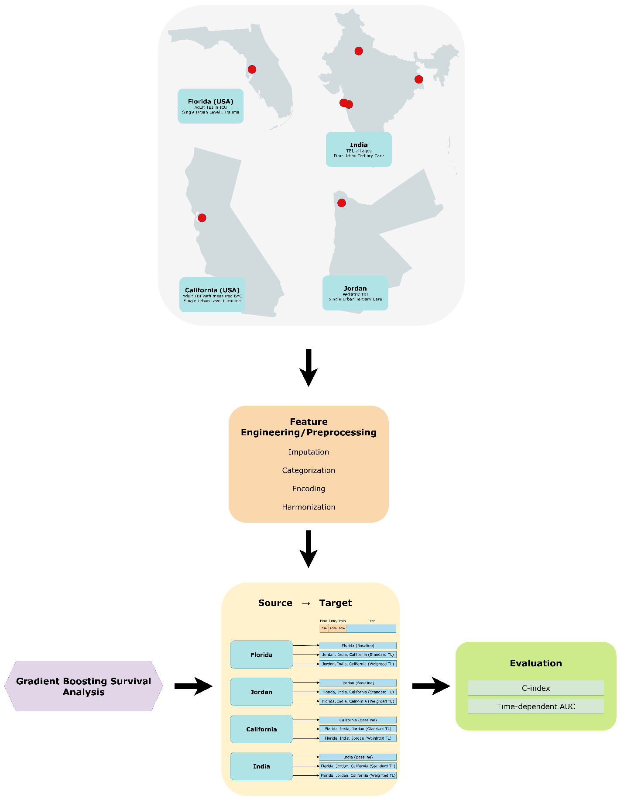
Figure 1. Overview of the study design and transfer learning framework.
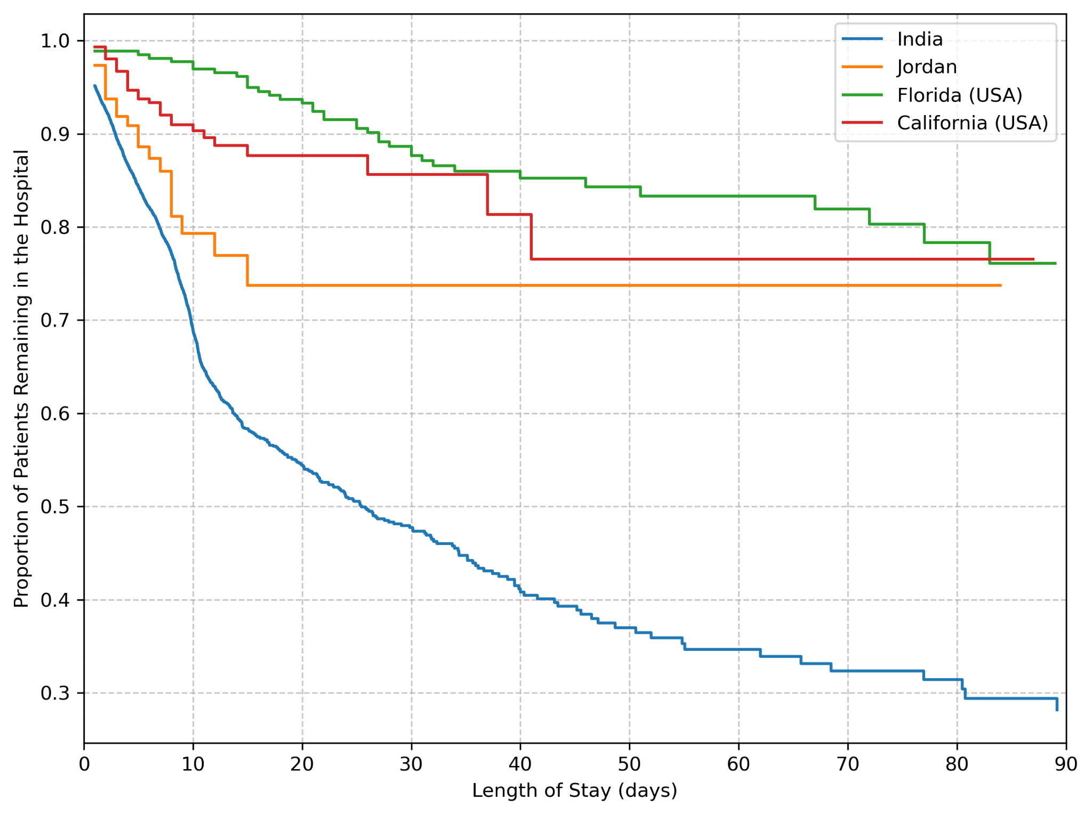
Figure 2. Length of Stay Profiles across cohorts.

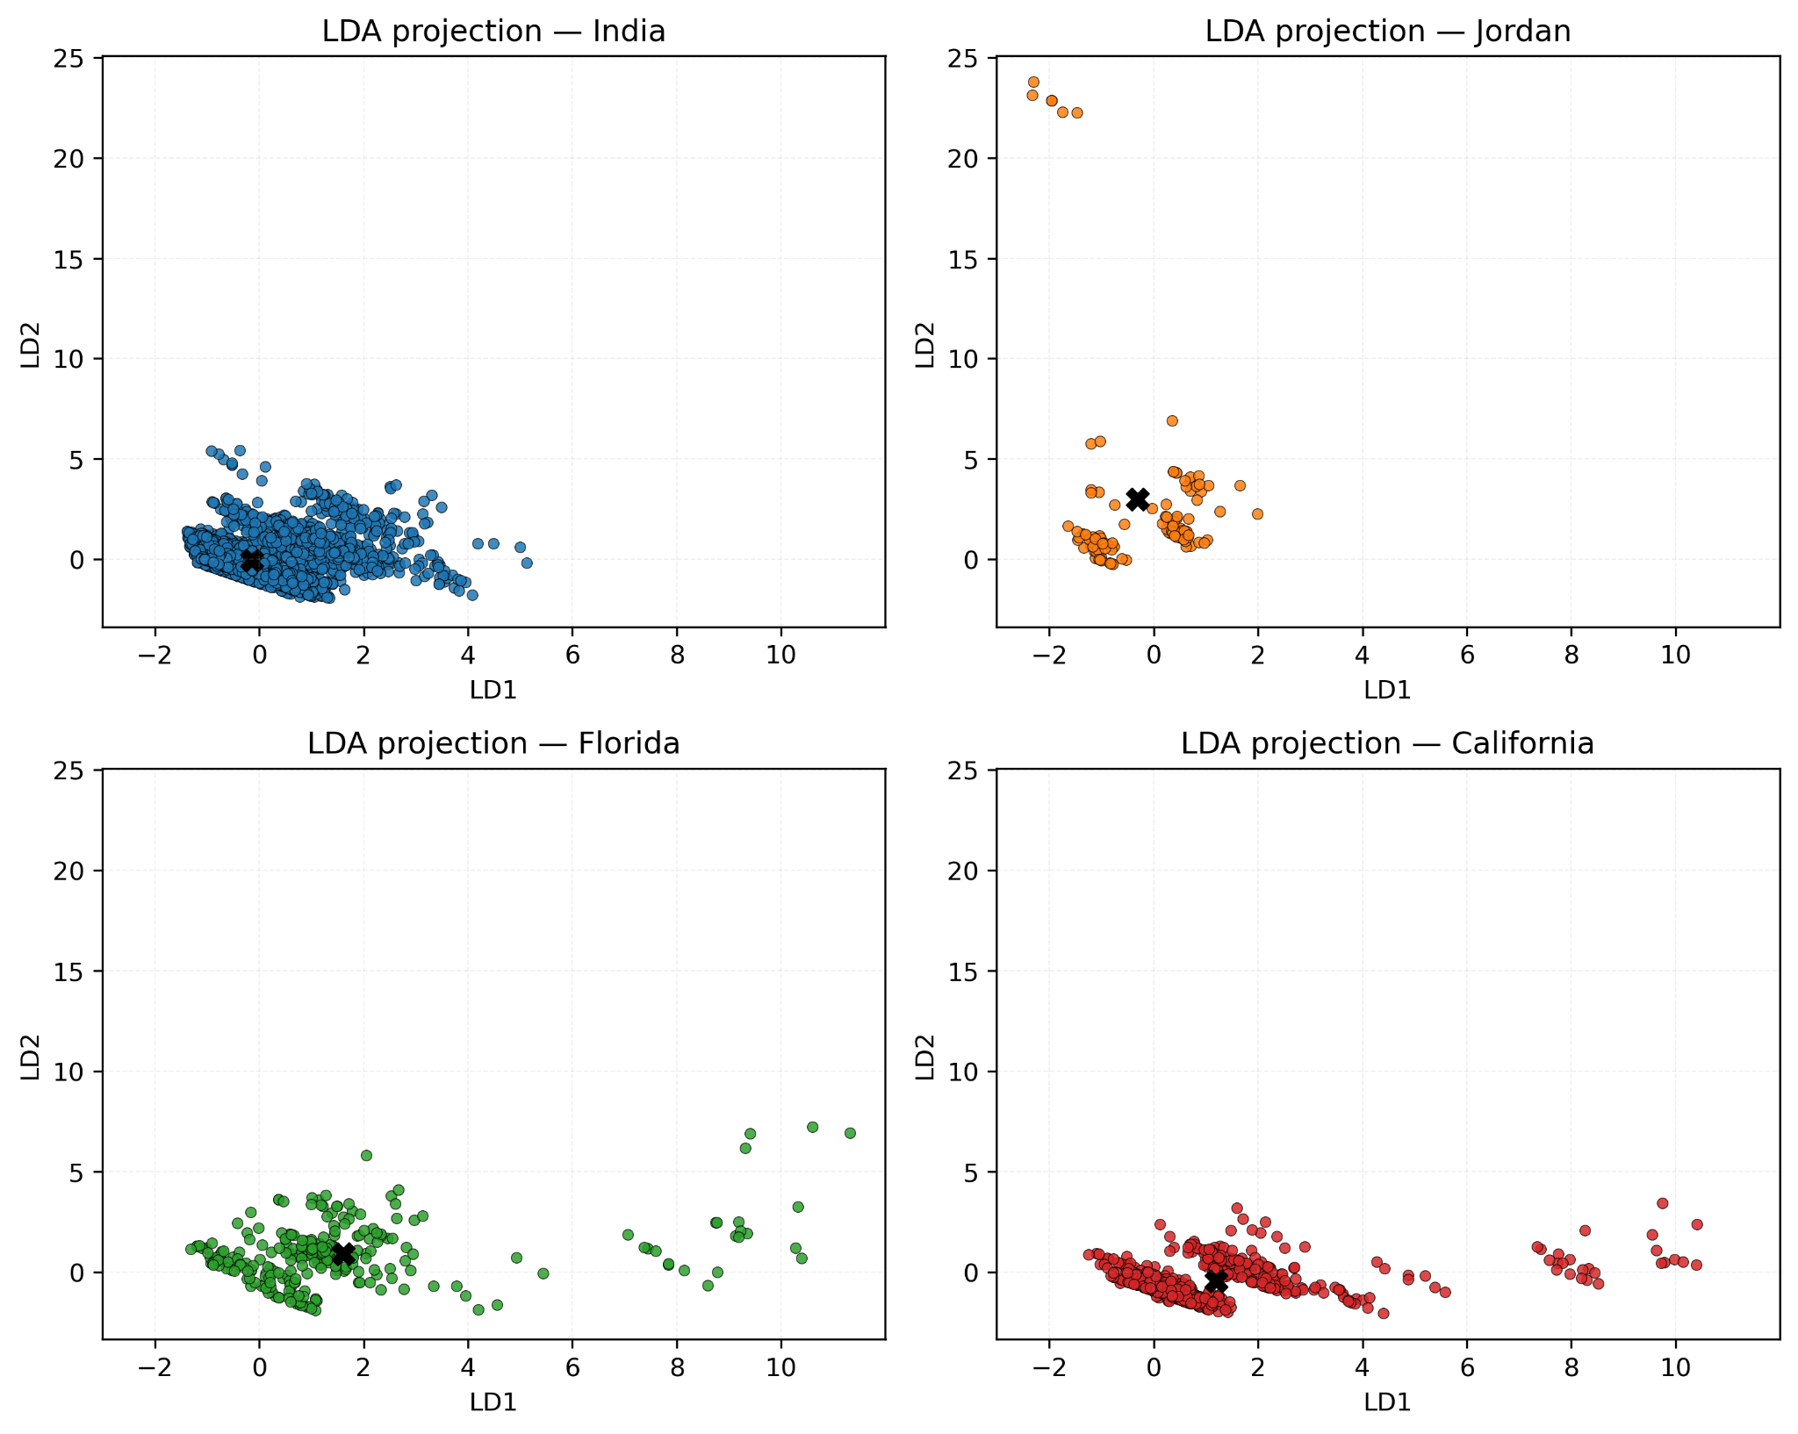
Figure 3. Linear Discriminant Analysis (LDA) projection of cohort distributions. Axes represent the first two linear discriminants (LD1 and LD2), with the black ‘X’ representing the centroid of the cohort.
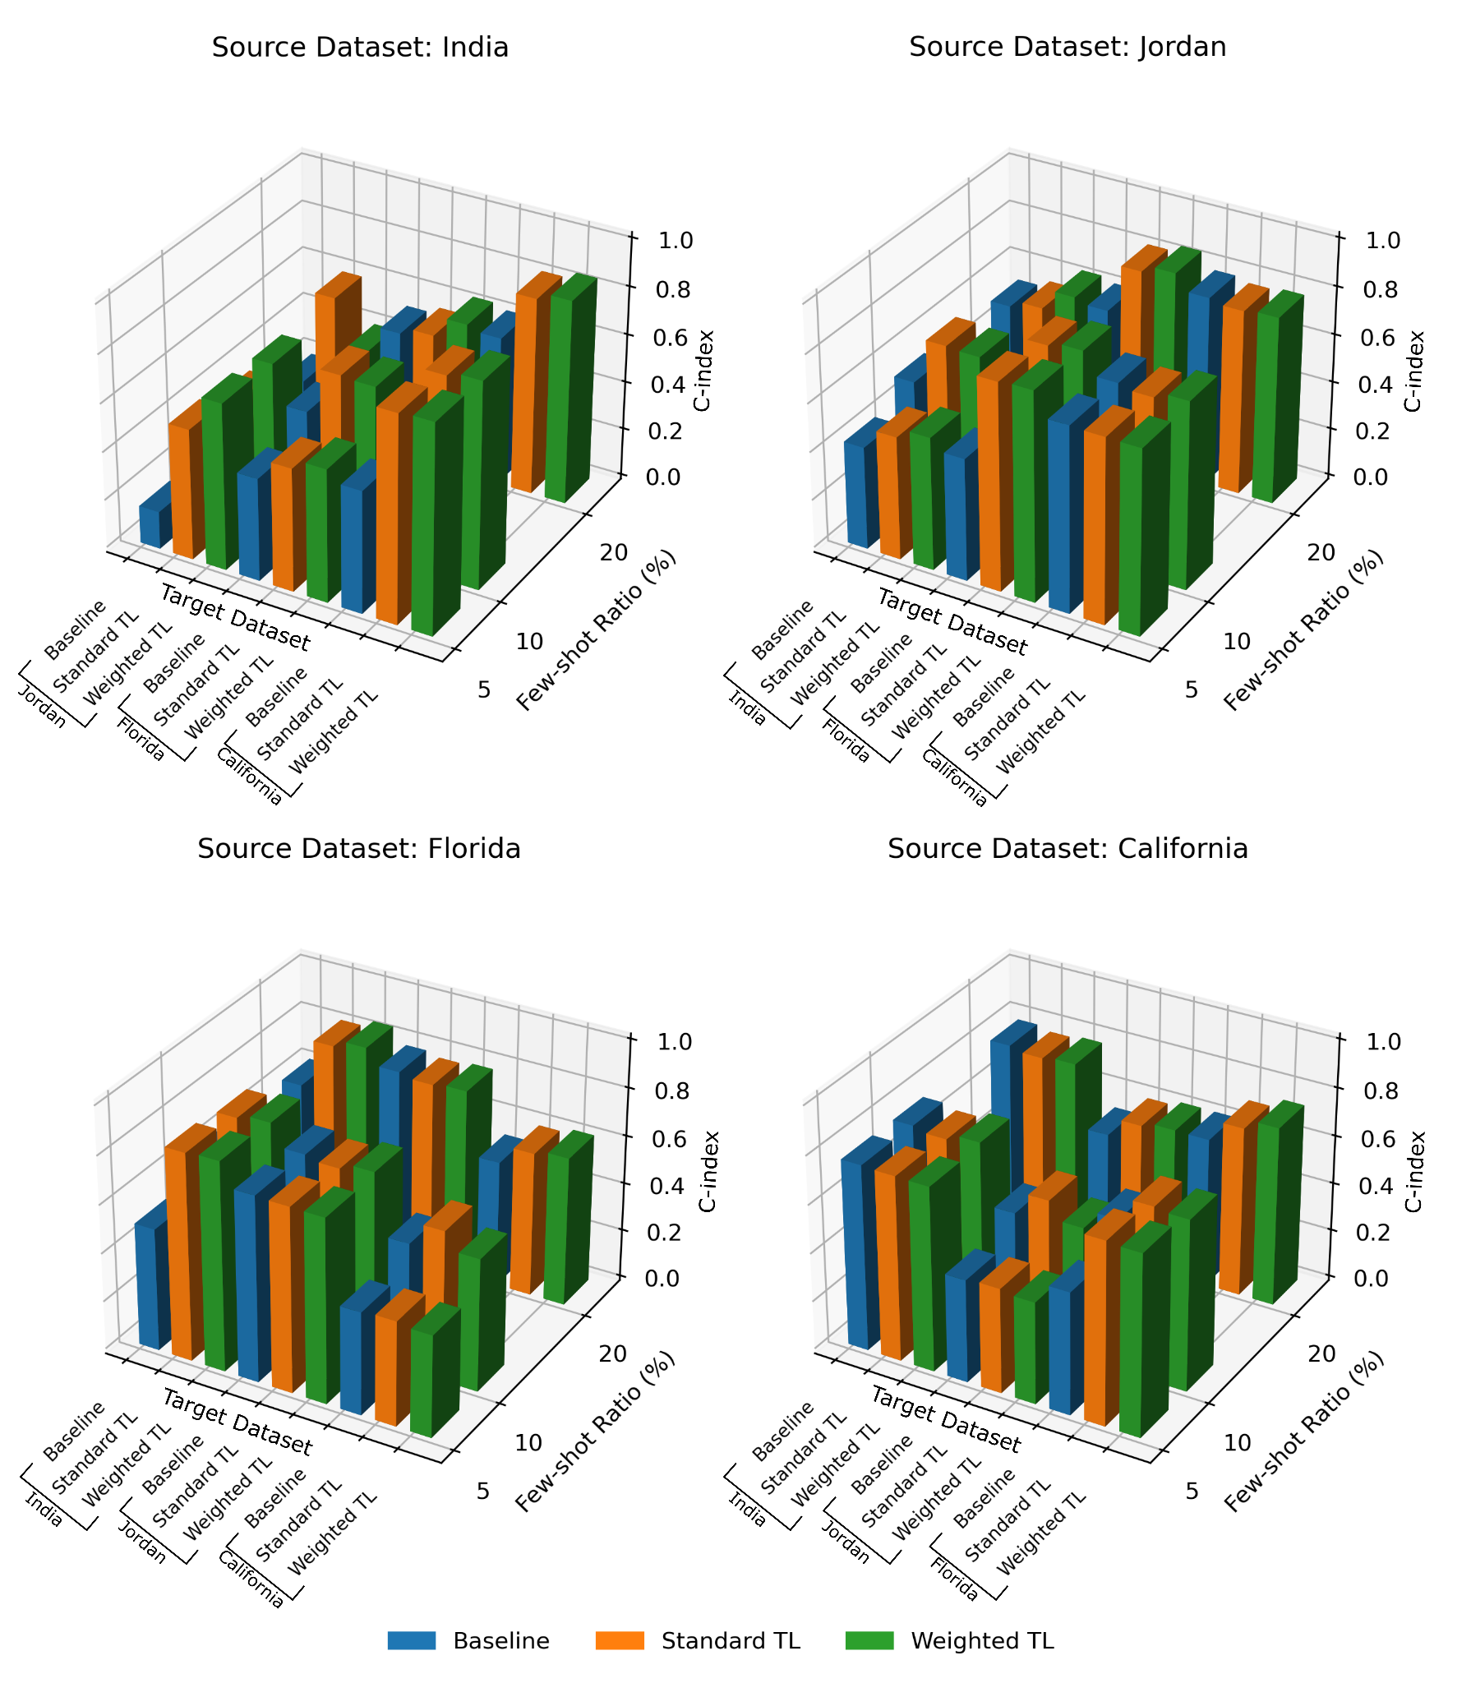
Figure 4. Performance of baseline, standard transfer learning (TL), and weighted TL models across source–target cohort pairs at varying few-shot ratios (5%, 10%, 20%). Results are presented as C-index values for each source dataset (India, Jordan, Florida, California).
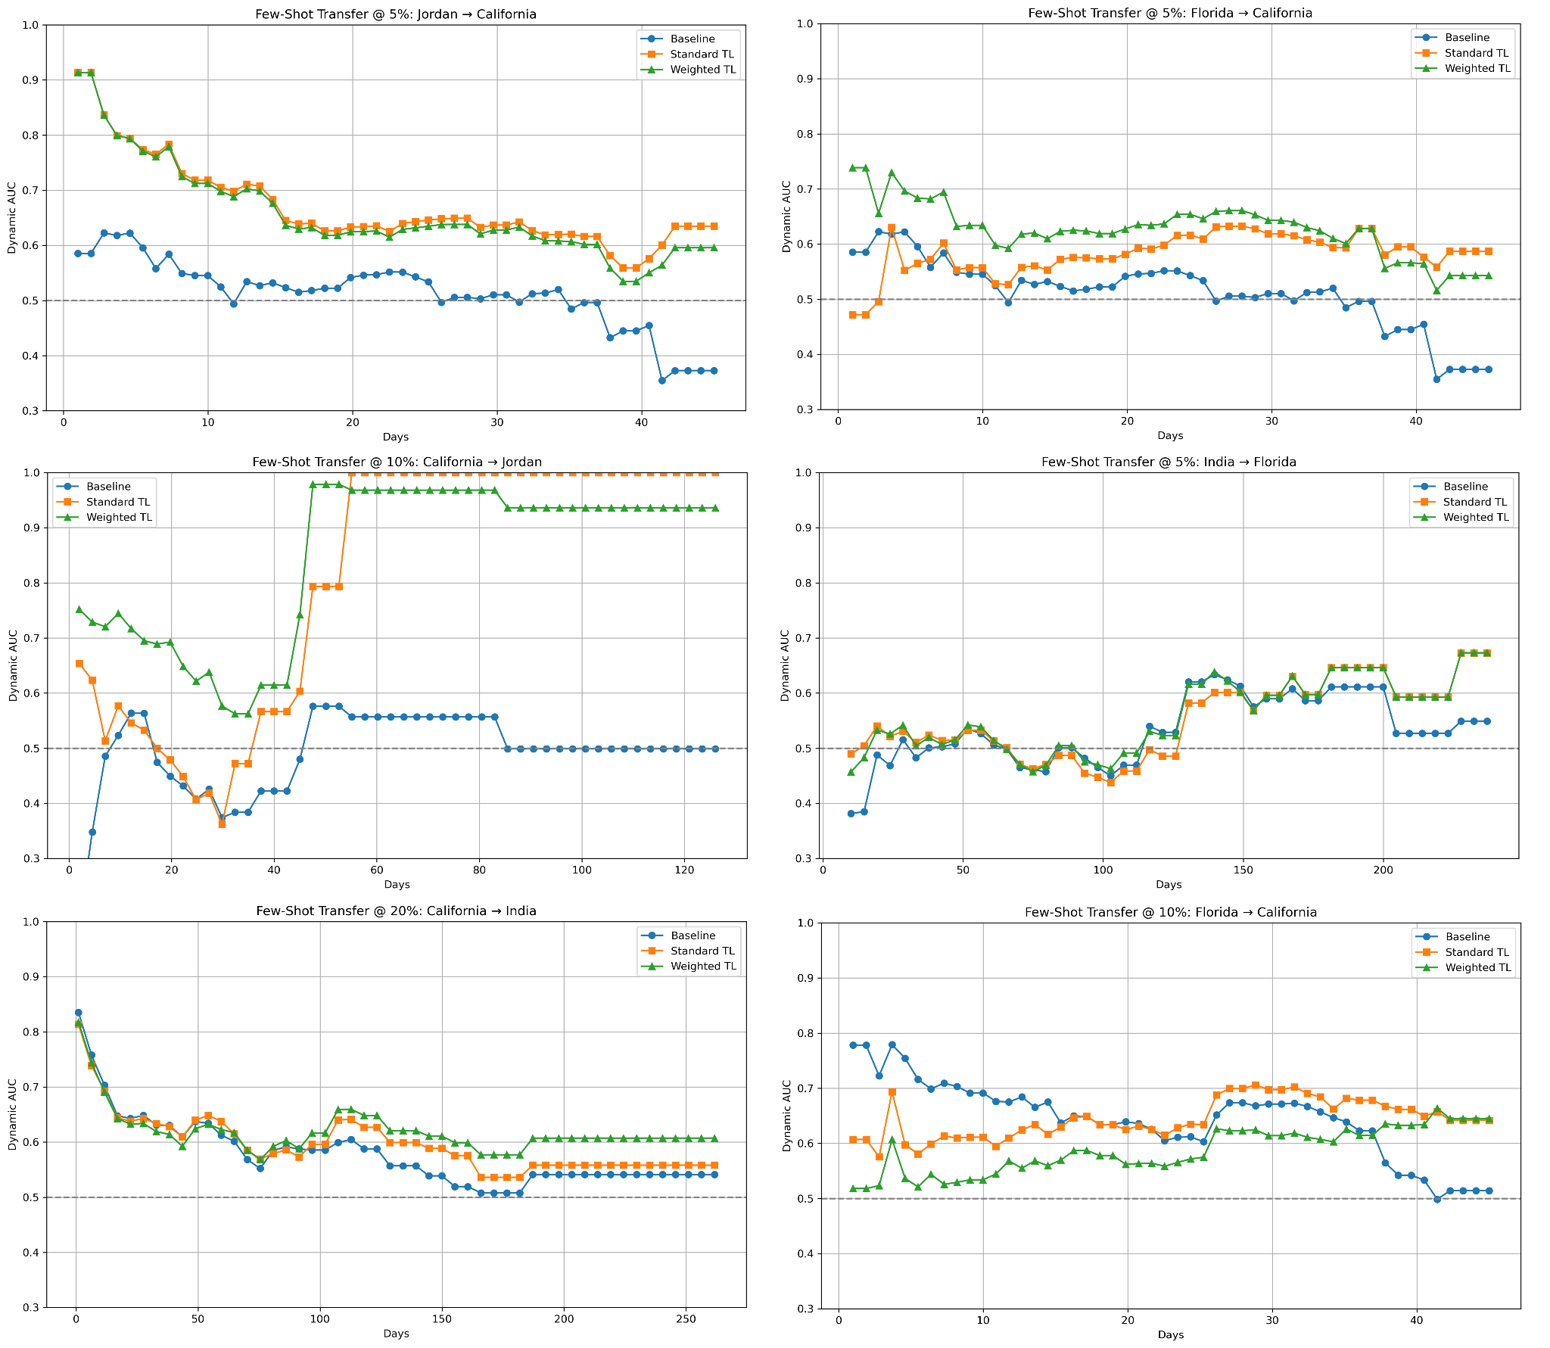
Figure 5. Examples of cumulative dynamic AUC curves for selected source–target transfer scenarios at varying few-shot ratios (5%, 10%, 20%). Each panel compares baseline models to standard and weighted transfer learning (TL) approaches across the hospitalization period.

Ethics Statement
The studies involving humans were approved by (IRB ID: STUDY006995 USF IRB) by the Institutional Review Board (IRB). The studies were conducted in accordance with the local legislation and institutional requirements. The ethics committee/institutional review board waived the requirement of written informed consent for participation from the participants or the participants' legal guardians/next of kin because A waiver of HIPAA authorization was also granted for this retrospective chart review, and a waiver of consent has been approved, given the study's retrospective nature

Contributions
S.B.: Conceptualization, methodology, data curation, formal analysis, funding acquisition, investigation, resources, software, validation, visualization, and writing—original draft preparation. J.V.: Conceptualization, data curation, and writing—review and editing. M.I.: Conceptualization, methodology, investigation, project administration, supervision, and writing—review and editing. M.B.: Conceptualization, methodology, investigation, project administration, supervision, writing—review and editing.

Declaration of generative AI in scientific writing
During the preparation of this work the author(s) used Grammarly in order to edit. After using this tool/service, the author(s) reviewed and edited the content as needed and take(s) full responsibility for the content of the published article.

Author Disclosure Statement
No competing financial interests exist.

Data Availability
The Florida dataset is available upon request from the corresponding author. The California, India, and Jordan datasets are open-access and cited. Code is available at https://github.com/shrinitbabel/TBI-transfer-learning.

Funding
This project was supported by USF Research, Innovation & Scholarly Endeavors (RISE).

